Experiment 2: Recrystallization and Melting Point
Often, an extraction method is used as the first step in purification. For example, you performed an extraction lab in Experiment 1, when you separated a three-component mixture using the separation method to obtain three crude products. Any remaining impurities are then removed by a method of final purification—these may include distillation or recrystallization. Recrystallization is a method of purifying impure solids, while distillation is a method of purifying impure liquids.
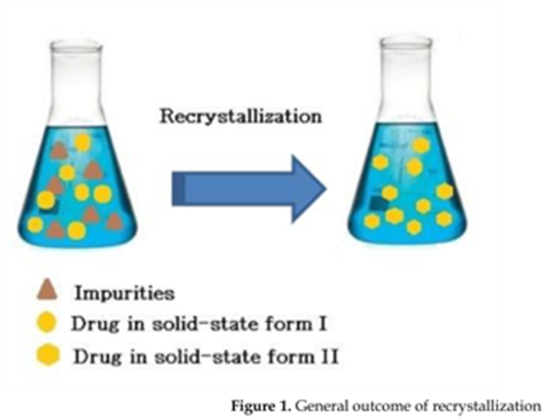
During today’s lab, you will be recrystallizing two of the three compounds recovered from the “Extraction” experiment in the last lab. The pure crystals obtained from recrystallization can have many forms and shapes. If you perform the recrystallization properly, you should observe shiny crystals in shapes including plates, diamond-shaped placards, rings, needles, orthorhombic, and many others. The actual crystal shape of a pure compound is given in section C of the CRC Handbook, or in the Merck Index. However, if you cool the solution too quickly, or have done something else to induce premature recrystallization, then you may produce a fine powder with no crystal shape or form, which could put the purity of your product into question.
Note: The CRC Handbook is available online via Library Sources (left side
menu) in Quercus course
The solvent used in recrystallization is very important. Why? What makes an ideal solvent?
(Hint: See Appendix)

Suppose you don’t know that your product is impure. How would you find out? What would be indicating physical property? What are sources of impurities? (Hint: See Appendix)

Recrystallization Procedure:
1. Start the recrystallization setup for compound B:
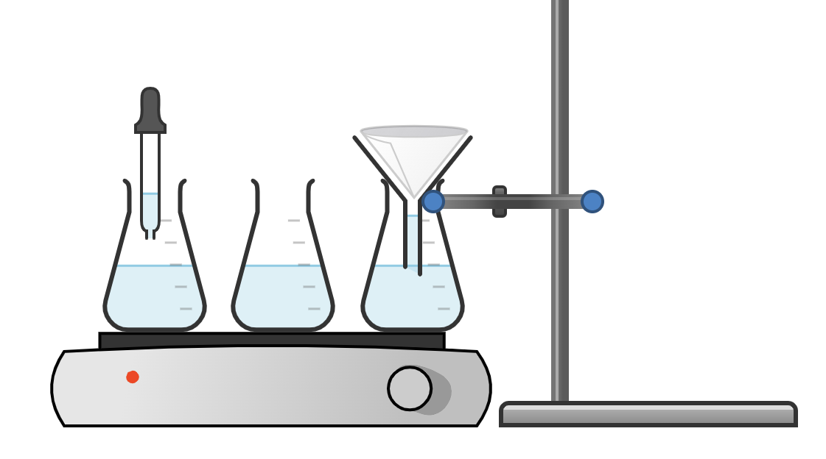
Place your 125 ml Erlenmeyer flask containing the crude product on a heating mantle, along with two other 125 ml Erlenmeyer flasks. To one of those Erlenmeyer flasks, add roughly 40 ml of water and to another empty Erlenmeyer flask, add 20 ml of water along with your washed glass funnel and fluted filter paper. Why do you think this is necessary? Think about the concept of recrystallization.
- To the Erlenmeyer flask containing the product, add a small amount of water (~5ml) just to prevent the product from burning and turn up the heat to 100 °C to get the boiling process started.
- Once boiling begins, using a clean pasteur pipette, add in small amounts of hot water to the crude product (2 full pipettes at a time) to dissolve it. Add, and then observe to see if all the crude product has dissolved; if not, add more aliquots of boiling hot solvent. DO NOT ADD TOO MUCH SOLVENT as this will lead to unsuccessful recrystallization. Only add enough solvent to dissolve all of the product!
- Once the crude product has been completely dissolved, there should be no visible clumps. Observe the volume of the solution and add 25% more solvent to the Erlenmeyer flask (why is this necessary?).
- Making sure the Erlenmeyer flask with the funnel and filter paper is hot; empty out the water in the Erlenmeyer flask with the funnel into another beaker and immediately gravity filter the Erlenmeyer flask with the dissolved product into the funnel through the filter paper. Very important that we keep this Erlenmeyer flask with the funnel hot whilst we transfer our crude solution. WHY?
- Once transferred, take the Erlenmeyer flask off the heat and let it cool slowly to room temperature to allow for recrystallization. This should take approximately 20 minutes.
- Once cooled to room temperature, place the Erlenmeyer flask into an ice bath. Using vacuum filtration, separate the crystals and let it dry for 10 minutes. Collect the crystals in a plastic bag and take their weight. Take its melting point and note down in your notebook.
- REPEAT the recrystallization setup for compound A using ETHANOL as your solvent.

Melting Point Determination for All Three Compounds
- Take the three compounds obtained from your extraction and recrystallizations and insert them into melting point capillary tubes.
- Set melting point machine to measure the compounds’ melting point based on literature values for the melting point of the three compounds.
- Write down their melting point ranges and identify the compounds by matching them with SDS-recorded physical properties. (If the solids do not melt at their supposed melting points, what could have altered the melting points?)

Pre-lab questions:
- Describe the recrystallization steps.
- During recrystallization, what happens if you add too much hot solvent?
- In recrystallization, if crystals are not forming, scratching the side of the beaker with a glass rod can promote their formation. Why might this be the case?
- Should you boil for too long, what will happen, and what can you do?
- What’s the purpose of an extra 25% solvent?
- Wouldn’t vacuum filtration be more efficient when filtering the hot recrystallization solution in step 5? Speaking of efficiency, why do you to gravity filter in small portions? Why must you filter immediately?
- What is the difference between gravity and vacuum filtration? When is each used?
- What is considered a good recrystallization solvent?
- Why do you need to cool the solution to room temperature before putting it in the ice bath?
- What do impurities do to a) the melting range and b) the melting point of a pure compound? Why?
Post lab questions:
- You should notice that compound C has a melting point that is beyond what is expected. What are some reasons you can think of that caused the melting point of compound C to be off?
- What would happen if you did not allow the recrystallization to cool slowly to room temperature?
- Discuss the advantages and limitations of using recrystallization as a final purification step for solids.
- If your compound does not crystallize out of solution what are the factors that could have caused this? How can you aid in crystallization using physical means?
- What solvent did you use to recrystallize each component? Why do you think these are good solvents for these compounds?
- Why is it necessary to pour the homogeneous crude and solvent mixture in hot condition?
- During vacuum filtration, why was it necessary to use cold solvent to wash the crystals?
- What are the possible reasons for obtaining a low yield?
- What can be the reason(s) of obtaining premature crystals?

References:
(1) Murov, S. Experiments and Exercises in Organic Chemistry: A Challenge Oriented Approach; http://murov.info/orglab/11-e6.pdf.
(2) Experiments and Exercises in Organic Chemistry Lab Book. Murov.info. http://murov.info/orglab.htm (accessed 2024-07-26).

Recrystallization and Melting Point Data Sheet
Name Day Wk Rm Space: TA:
Uncovering Unknown Identities:

Identity of Compound A:

Identity of Compound B:

Identity of Compound C:
  - Compound “A”
Solvent used:
Yield of crude product (from last lab) (g):
Percent recovery of crude (crude/original 1.0 g) x 100:
Yield of pure product (from this lab) (g):
Percent recovery of pure product (pure/original 1.0g):
Crystal Form:
  - Compound B:
Solvent used:
Yield of crude product (from last lab) (g) :
Percent recovery of crude (crude/original 1.0 g) x 100 :
Yield of pure product (from this lab) (g) :
Percent recovery of pure product (pure/original 1.0g) :
Crystal Form:
Melting Point:
Melting point of Compound A: Melting point of Compound B: Melting point of Compound C:
Discuss the purity of each compound by comparing their experimental melting points to their literature values from your physical properties table. Give explanations for accurate melting points vs. inaccurate melting points.

